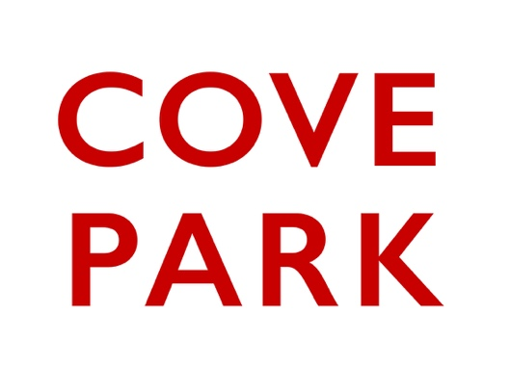
Access Statement
- A personalised access statement allows an individual to provide the information required to ensure the participant can fully realise their potential and operate within all activity and structures that are required.
- This is an active document that should be updated as required.
- An access statement can be provided by anyone and does not have to be focused on disability.

In this document you can provide your access requirements for taking part in a Cove Park residency or event. Under each heading are examples of things to consider but this is personal to you and your access needs. Please be as detailed as possible but any sections that do not apply can be left blank. This form can also be submitted in video and audio formats.

Name:
Residency/Project:

Communication: email, phone calls, face-to-face in person or online
Please provide information on your access requirements:
Examples may include: If interpreters are required, Preferred method of communication and format i.e electronic &/or hard copy

Physical and Environmental Factors
Please provide information on your access requirements:
Examples may include: Requires level access and an accessible bathroom, Certain lighting, sound or heating elements may trigger sensory impairments

Attending Events or Meetings
Please provide information on your access requirements:
Examples may include: A personal assistant or support animal is required to move around the space, Seating in a certain location e.g near bathroom or in-hearing loops best pick up location

Delivering at Events / Artistic Practice
Please provide information on your access requirements:
Examples may include: Set timeframes for information and schedules requirements from all parties, Time to familiarise with the space and resources to deliver the event

Written Reports, Surveys and Evaluations
Please provide information on your access requirements:
Examples may include: Preferred format for delivering information e.g has dyslexia so not a lot of written information, Document must be screen reader compatible

Travel and Transport
Please provide information on your access requirements:
Examples may include: Preferred form of transport and assistant required from the service provider, Preference to travel outside of rush hour, Length of time you can travel without breaks and or recovery time required, Equipment you will bring with you

Accommodation
Please provide information on your access requirements:
Examples may include: The type of accessible room you require e.g, level access, wet room or walk in shower, bathtub, visual or touch alarm system, room temperature control, Equipment within the room, e.g, shower seat, host, grab rails, basic kitchen facilities

Personal Assistant
Please provide information on your access requirements:
Examples may include: When you need a PA. If you require travel & accommodation for your PA

Additional Information
Please provide information on your access requirements:
Examples may include: Anything not already covered that you think it would be helpful for Cove Park to know or provide. e.g needs fluctuate with condition

Last updated: 18 April 2022

Data Protection
Cove Park complies with data protection law in the UK. You have the right to ask for a copy of the information we hold on you, and the right to ask us to correct any inaccuracies in that information. If you have concerns about how we have used your personal information, you also have the right to complain to a privacy regulator.

